“The George Taylor IV Grant”
NRA Whittington Center Funding Available
Each year our club awards the George Taylor IV Grant to provide financial assistance to youths to attend the two-week Adventure Camp program at the NRA Whittington Center in Raton, New Mexico. The 2026 camp will offer two sessions, one from June 14 to June 26, and the second from June 28 to July 10. Our club has reserved two positions in the second session for grant applicants.
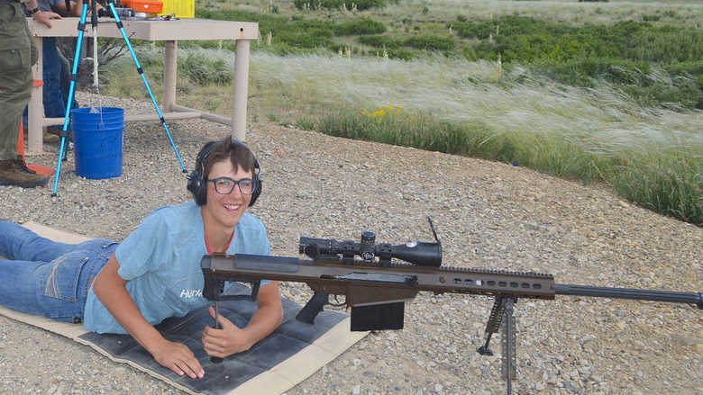
The sponsorship is open to youths who will be aged 13 by the first day of their session and not turn 18 on or before the final day. Applicants must have a parent, grandparent, or legal guardian who is a member of the club, participate in a club sanctioned youth program, or be a member of the Mt. Lebanon High School Rifle Team. The grant provides $650 toward the $1,300 camp registration and reimburses a portion of your travel expenses.
During the program, participants learn from highly trained NRA Whittington Adventure instructors who teach the fundamentals of pistol, rifle, muzzleloading, and shotgun shooting skills with safety always foremost in mind. Campers are introduced to competitive shooting, rifle and pistol silhouette, and bullseye disciplines, plus skeet and trap shooting skills. Each camper will fire more than 1,200 rounds of ammunition during their stay.
To be considered for the grant, please complete the grant application that follows this information and return it, along with a 200-word essay on how you will benefit from attending the camp, and a list of your extracurricular activities and shooting experience by Dec. 31, 2025.

“The George Taylor IV Grant”
2026 NRA Adventure Camp Grant Application Form
Applicant Name:
Age During 2025 Camp Dates (6/28/26-7/10/26):
Applicant’s Mailing Address:
Applicant’s Phone Number:
Applicant’s Email Address:
Parent/Grandparent/Guardian’s Information | Name:
Parent/Grandparent/Guardian’s Information | Phone Number:
Parent/Grandparent/Guardian’s Information | Email Address:
Extracurricular Activities
- -  - -  - -  - - | - -  - -  - -  - -
Shooting Experience
- -  - -  - -  - - | - -  - -  - -  - -

Please complete the grant application and return it, along with a 200-word essay on how you expect to benefit from attending the camp, by Dec. 31, 2025.
Application material may be emailed to dmscgrants@gmail.com, or delivered via U. S. Mail to:
The Dormont-Mt. Lebanon Sportsmen’s Club, Inc.
P.O. Box 12692
Pittsburgh, PA 15241-0682

LATE APPLICATIONS WILL NOT BE CONSIDERED!!

